**UNIT-V**

**Overview of World Energy Scenario**

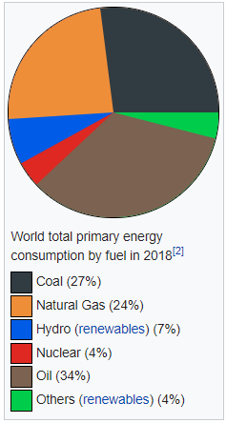

**World energy consumption** is the total [energy](https://en.wikipedia.org/wiki/Energy) produced and used by the entire human [civilization](https://en.wikipedia.org/wiki/Civilization). Typically measured per year, it involves all energy harnessed from every [energy source](https://en.wikipedia.org/wiki/Energy_source) applied towards humanity's endeavors across every single industrial and technological sector, across every country. It does not include energy from food, and the extent to which direct biomass burning has been accounted for is poorly documented. Being the power source metric of civilization, world energy consumption has deep implications for humanity's socio-economic-political sphere.

Institutions such as the [International Energy Agency](https://en.wikipedia.org/wiki/International_Energy_Agency) (IEA), the U.S. [Energy Information Administration](https://en.wikipedia.org/wiki/Energy_Information_Administration) (EIA), and the [European Environment Agency](https://en.wikipedia.org/wiki/European_Environment_Agency) (EEA) record and publish energy data periodically. Improved data and understanding of world energy consumption may reveal systemic trends and patterns, which could help frame current energy issues and encourage movement towards collectively useful solutions.

* Overview Of world energy Scenarios:- The scenarios usually report energy quantities (e.g., primary energy production and consumption by type), electricity generation, energy demand by sector of economy, energy trade flows, investments, and the resulting CO2 emissions.
* Energy is one of the major inputs for the economic development of any country.
* In the case of the developing countries, the energy sector assumes a critical importance in view of the ever-increasing energy needs requiring huge investments to meet them.
* Energy can be classified into several types based on the following criteria

• Primary and Secondary energy

• Commercial and Non commercial energy

• Renewable and Non-Renewable energy

* Primary and Secondary Energy:- Primary energy sources are those that are either found or stored in nature. Common primary energy sources are coal, oil, natural gas, and biomass (such as wood). Other primary energy sources available include nuclear energy from radioactive substances, thermal energy stored in earth's interior, and potential energy due to earth's gravity. Primary energy sources are mostly converted in industrial utilities into secondary energy sources; for example coal, oil or gas converted into steam.

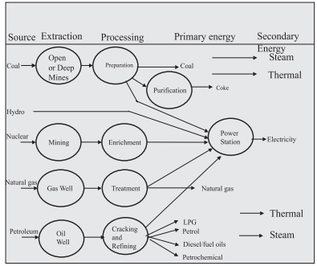

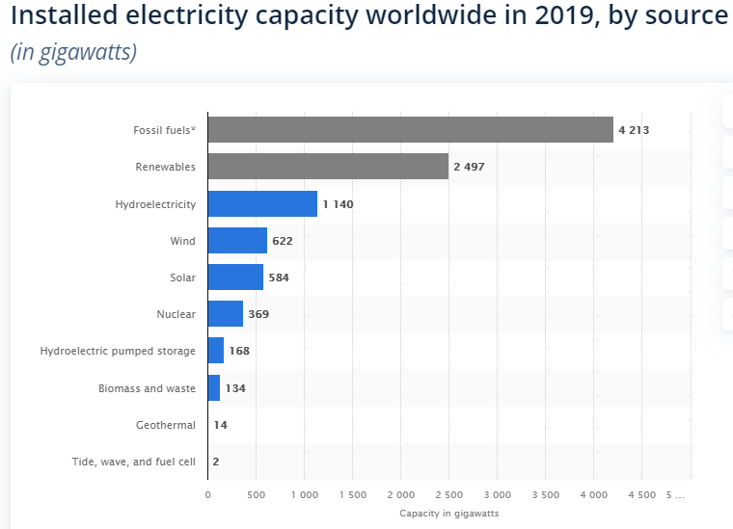

Indian Energy Scenario:-

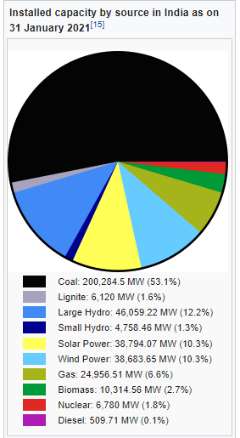

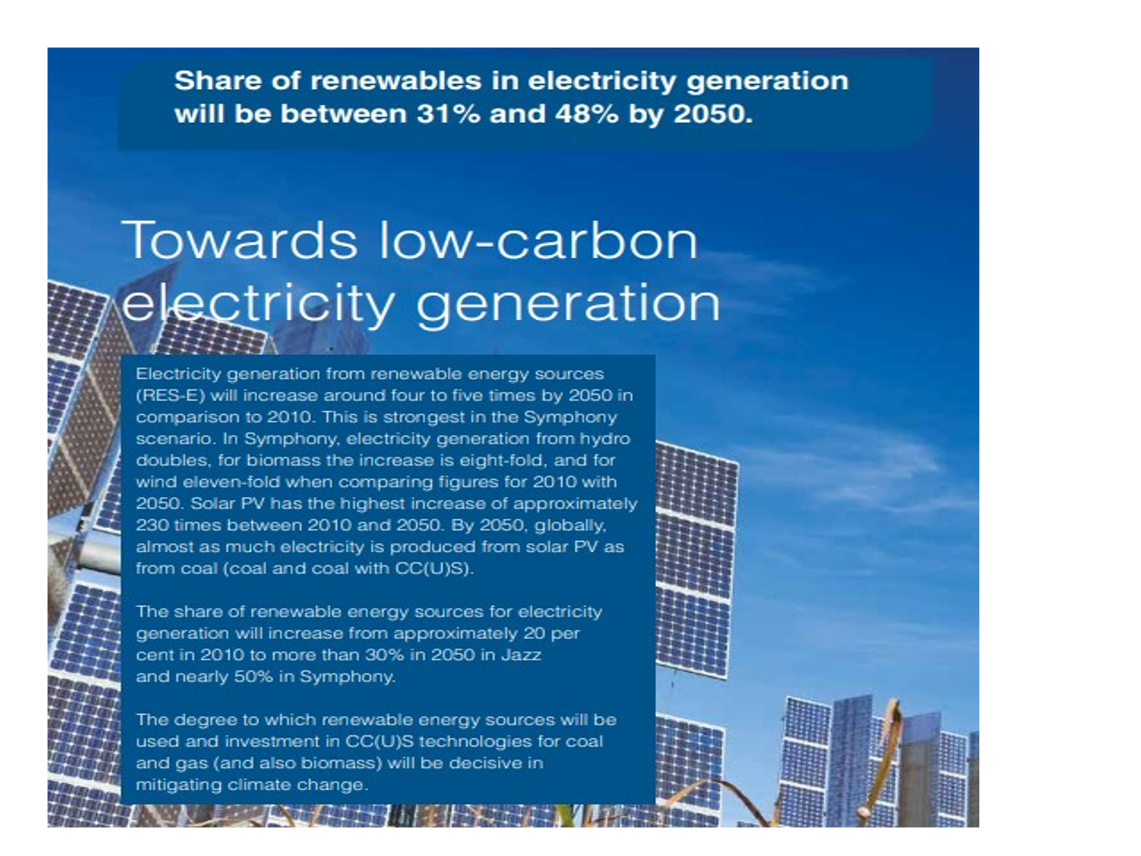

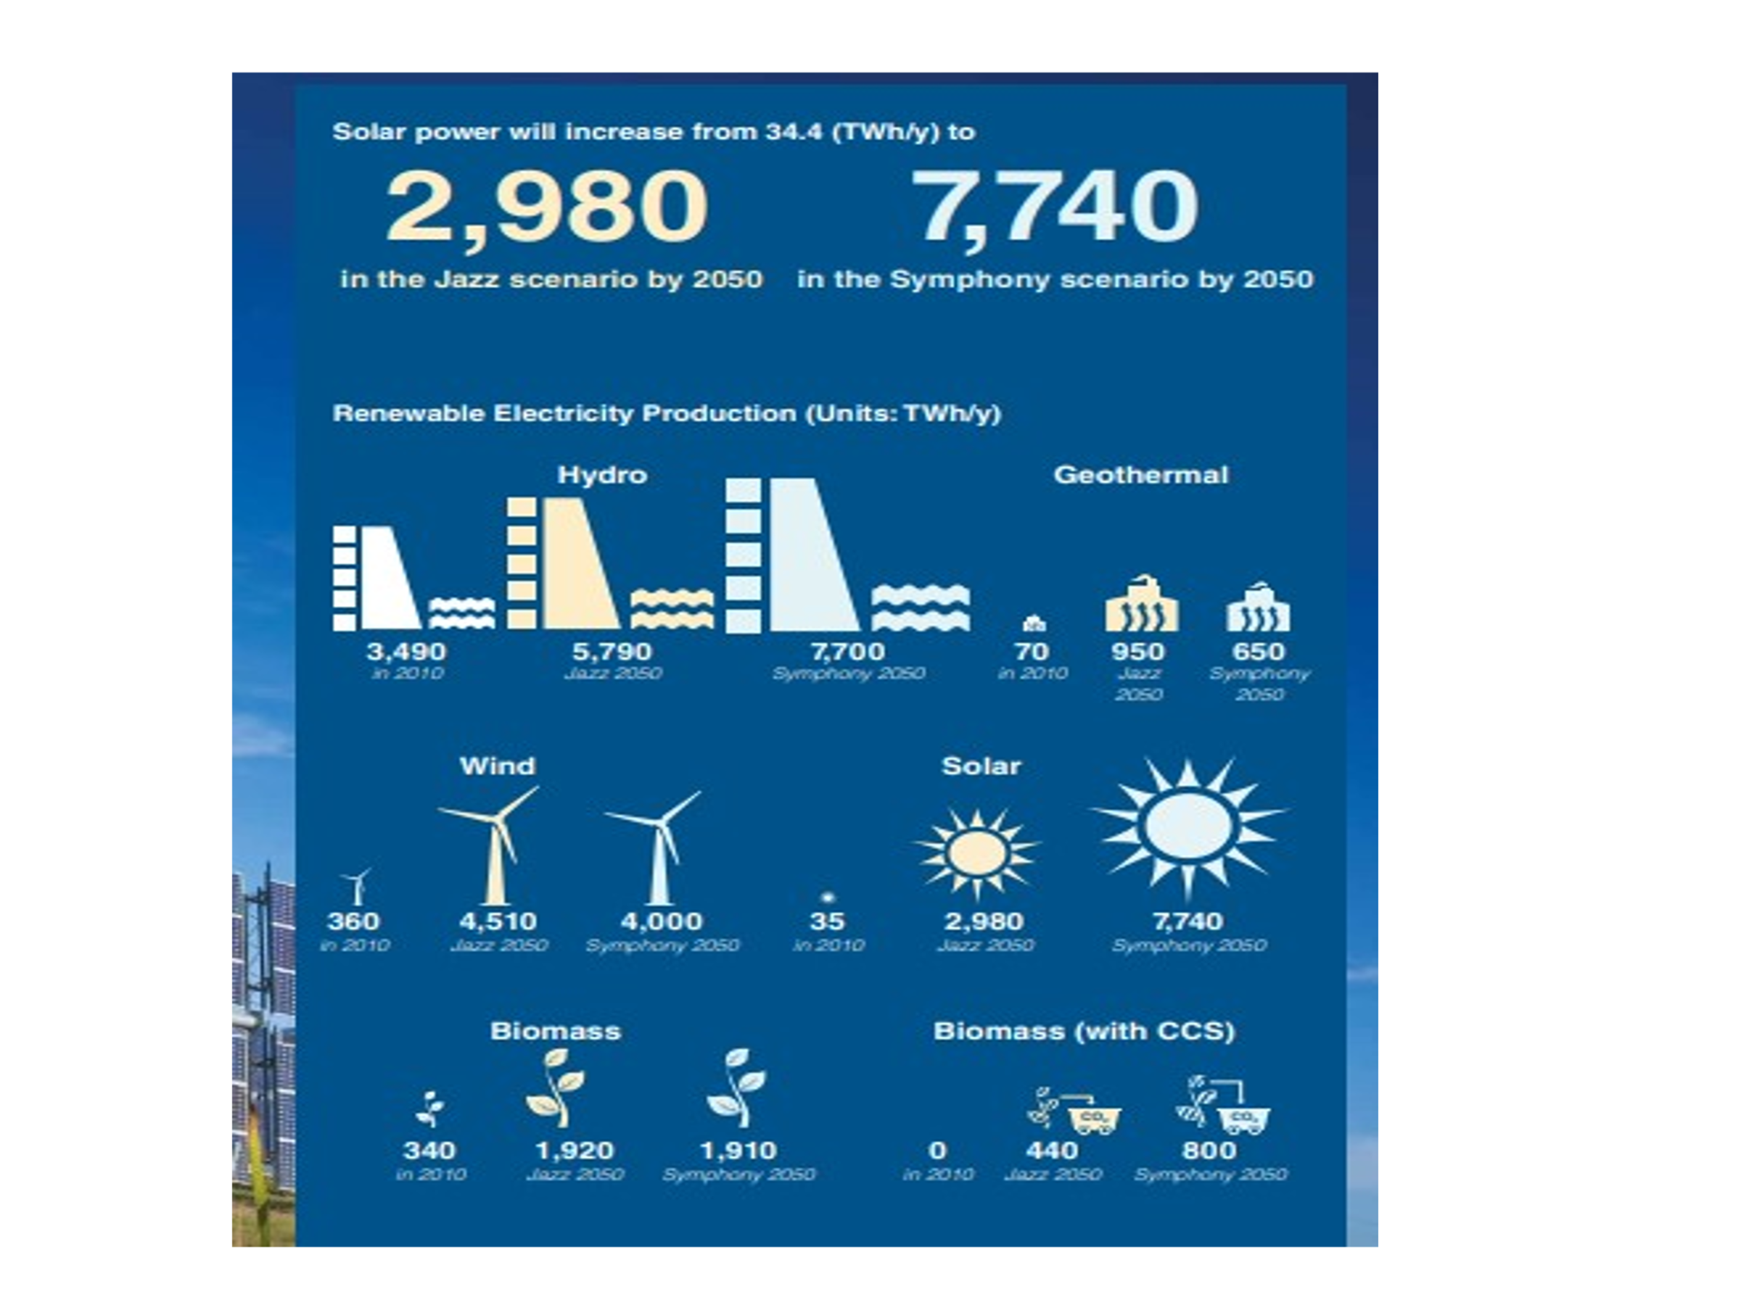

**NUCLEAR RADIATION**

Nuclear radiation refers to the particles and [photons](https://www.thoughtco.com/definition-of-photon-605908) emitted during reactions that involve the [nucleus](https://www.thoughtco.com/definition-of-nucleus-605434) of an [atom](https://www.thoughtco.com/definition-of-atom-and-examples-604373). Nuclear radiation is also known as ionizing radiation or ionising radiation (depending on the country). The particles emitted by nuclear reactions are sufficiently energetic that they can remove electrons from atoms and molecules and ionize them.

Nuclear radiation includes gamma rays, x-rays, and the more energetic portion of the electromagnetic spectrum. Ionizing subatomic particles released by nuclear reactions include alpha particles, beta particles, neutrons and cosmic rays.

Our eyes are only evolved so as to respond to optical and most prominently blue light. And thus, we cannot see the rest of the electromagnetic spectrum, which also includes nuclear radiation, like beta, gamma and alpha rays. **Nuclear radiation** arises from hundreds of different kinds of unstable atoms. While many exist in nature, the majority are created in **nuclear** reactions. Ionizing **radiation** which can damage living tissue is emitted as the unstable atoms (radionuclides) change ('decay') spontaneously to become different kinds of atoms.

## Nuclear Radiation Example

During the fission of U-235 the nuclear radiation that is released contains neutrons and gamma ray photons.

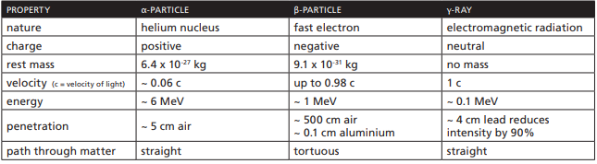

**What is the fuel cycle?**

The various activities associated with the production of electricity from nuclear reactions are referred to collectively as the nuclear fuel cycle. The nuclear fuel cycle starts with the mining of uranium and ends with the disposal of nuclear waste. With the reprocessing of used fuel as an option for nuclear energy, the stages form a true cycle.

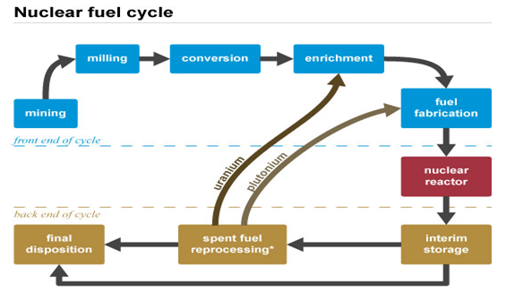

The nuclear fuel cycle, also called nuclear fuel chain, is the progression of [nuclear fuel](https://en.wikipedia.org/wiki/Nuclear_fuel) through a series of differing stages. It consists of steps in the *front end*, which are the preparation of the fuel, steps in the *service period* in which the fuel is used during reactor operation, and steps in the *back end*, which are necessary to safely manage, contain, and either [reprocess](https://en.wikipedia.org/wiki/Nuclear_reprocessing) or dispose of [spent nuclear fuel](https://en.wikipedia.org/wiki/Used_nuclear_fuel). If spent fuel is not reprocessed, the fuel cycle is referred to as an *open fuel cycle* (or a *once-through fuel cycle*); if the spent fuel is reprocessed, it is referred to as a *closed fuel cycle*.

* [Uranium recovery](https://www.nrc.gov/materials/uranium-recovery.html) to extract (or *mine*) uranium ore, and concentrate (or *mill*) the ore to produce a uranium ore concentrate, sometimes called U3O8 or "[yellowcake](https://www.nrc.gov/reading-rm/basic-ref/glossary/yellowcake.html)"
* [Conversion](https://www.nrc.gov/materials/fuel-cycle-fac/ur-conversion.html) of uranium ore concentrate into uranium hexafluoride (UF6)
* [Enrichment](https://www.nrc.gov/materials/fuel-cycle-fac/ur-enrichment.html) to increase the concentration of uranium-235 (U235) in UF6
* [Fuel fabrication](https://www.nrc.gov/materials/fuel-cycle-fac/fuel-fab.html) to convert natural and enriched UF6 into UO2 or uranium metal alloys for use as fuel for nuclear reactors.
* Use of the fuel in [reactors](https://www.nrc.gov/reactors.html) (nuclear power, research, or naval propulsion)
* [Interim storage](https://www.nrc.gov/waste/spent-fuel-storage.html) of spent nuclear fuel.
* [Reprocessing](https://www.nrc.gov/materials/reprocessing.html) (or *recycling*) of [high-level waste](https://www.nrc.gov/waste/high-level-waste.html) (currently not done commercially in the U.S.)[[1]](https://www.nrc.gov/materials/fuel-cycle-fac/stages-fuel-cycle.html)
* Final disposition ([disposal](https://www.nrc.gov/waste/hlw-disposal.html)) of used fuel or high-level waste

**WASTE AND PROLIFERATION**

**Nuclear waste** is the material that **nuclear** fuel becomes after it is used in a **reactor**. Nuclear energy produces radioactive waste. A major environmental concern related to nuclear power is the creation of radioactive wastes such as uranium mill tailings, spent (used) reactor fuel, and other radioactive wastes. These materials can remain radioactive and dangerous to human health for thousands of years.

The use of nuclear energy results in some waste products. There are three types of nuclear waste, classified according to their radioactivity: low-, intermediate-, and high-level. The vast majority of the waste (90% of total volume) is composed of only lightly-contaminated items, such as tools and work clothing, and contains only 1% of the total radioactivity. By contrast, high-level waste – mostly comprising used nuclear (sometimes referred to as spent) fuel that has been designated as waste from the nuclear reactions – accounts for just 3% of the total volume of waste, but contains 95% of the total radioactivity.

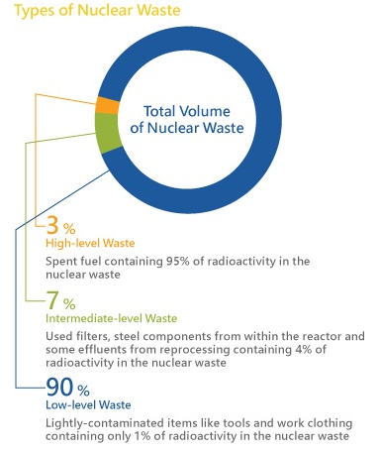

* **Low-level waste**:- Low-level waste (LLW) has a radioactive content not exceeding four giga-becquerels per tonne (GBq/t) of alpha activity or 12 GBq/t beta-gamma activity. LLW does not require shielding during handling and transport, and is suitable for disposal in near surface facilities.
* LLW is generated from hospitals and industry, as well as the nuclear fuel cycle. It comprises paper, rags, tools, clothing, filters, *etc.*, which contain small amounts of mostly short-lived radioactivity. To reduce its volume, LLW is often compacted or incinerated before disposal. LLW comprises some 90% of the volume but only 1% of the radioactivity of all radioactive waste.
* **Intermediate-level waste:-** Intermediate-level waste (ILW) is more radioactive than LLW, but the heat it generates (<2 kW/m3) is not sufficient to be taken into account in the design or selection of storage and disposal facilities. Due to its higher levels of radioactivity, ILW requires some shielding. ILW typically comprises resins, chemical sludges, and metal fuel cladding, as well as contaminated materials from reactor decommissioning. It makes up some 7% of the volume and has 4% of the radioactivity of all radioactive waste.
* **High-level waste:-** High-level waste (HLW) is sufficiently radioactive for its decay heat (>2kW/m3) to increase its temperature, and the temperature of its surroundings, significantly. As a result, HLW requires cooling and shielding. HLW arises from the 'burning' of uranium fuel in a nuclear reactor. HLW contains the fission products and transuranic elements generated in the reactor core. HLW accounts for just 3% of the volume, but 95% of the total radioactivity of produced waste. There are two distinct kinds of HLW:

1. Used fuel that has been designated as waste.

2. Separated waste from reprocessing of used fuel.

HLW is the focus of significant attention regarding nuclear power, and is managed accordingly.

* **Radioactive Waste Management:-** Nuclear power is the only large-scale energy-producing technology that takes full responsibility for all its waste and fully costs this into the product. The amount of waste generated by nuclear power is very small relative to other thermal electricity generation technologies. Used nuclear fuel may be treated as a resource or simply as waste. Nuclear waste is neither particularly hazardous nor hard to manage relative to other toxic industrial waste. Safe methods for the final disposal of high-level radioactive waste are technically proven.

**WHAT IS CLIMATE CHANGE?**

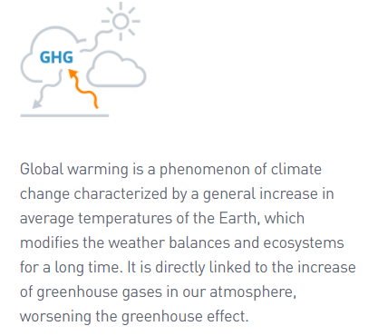

Climate change, also called global warming, refers to the rise in average surface temperatures on Earth. An overwhelming scientific consensus maintains that climate change is due primarily to the human use of fossil fuels, which releases carbon dioxide and other greenhouse gases into the air. The gases trap heat within the atmosphere, which can have a range of effects on ecosystems, including rising sea levels, severe weather events, and droughts that render landscapes more susceptible to wildfires. The Earth's average temperature is about 15C but has been much higher and lower in the past. Climate Change is the defining issue of our time and we are at a defining moment. From shifting weather patterns that threaten food production, to rising sea levels that increase the risk of catastrophic flooding, the impacts of climate change are global in scope and unprecedented in scale.

There are natural fluctuations in the climate but scientists say temperatures are now rising faster than at many other times.

The primary cause of climate change is the burning of fossil fuels, such as oil and coal, which emits greenhouse gases into the atmosphere—primarily carbon dioxide. Other human activities, such as agriculture and deforestation, also contribute to the proliferation of greenhouse gases that cause climate change.

**Climate change causes:-**

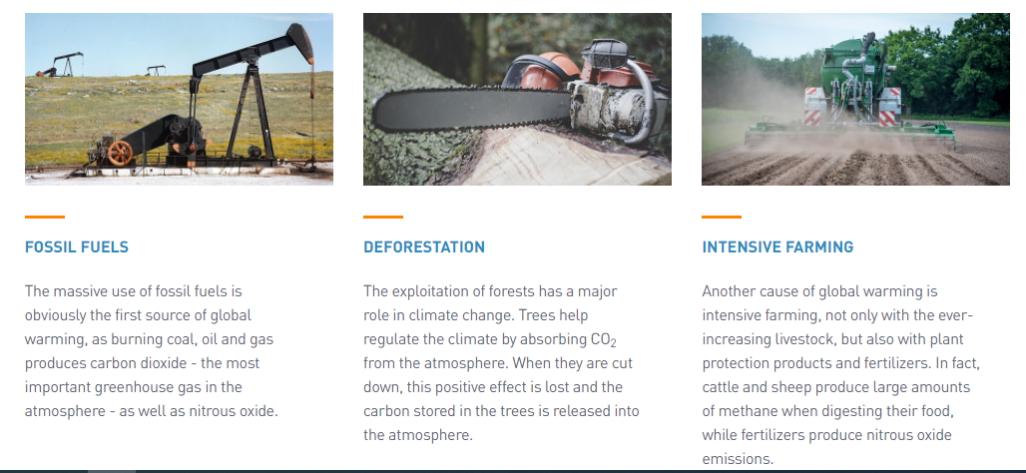

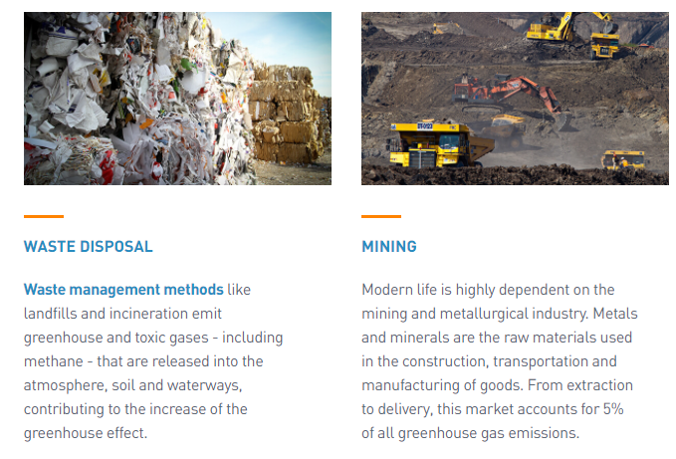

**What causes the Earth's climate to change?**

### Changes in the Earth’s orbit:- The Earth’s orbit around the Sun is an ellipse, not a circle but the ellipse changes shape.

1. **Changes in the orientation of the Earth’s axis of rotation:-** The Earth rotates around an axis (imagine a line that joins the north and south poles) but the Earth’s axis is not upright, it leans at an angle. This angle changes with time and over about 41 000 years it moves from 22.1 degrees to 24.5 degrees and back again.
2. **Quantity of greenhouse gases in the atmosphere**:- These include carbon dioxide, methane and water vapour these three, water vapour makes the greatest contribution to the greenhouse effect because there is more of it. These gases trap solar radiation (electromagnetic radiation emitted by the Sun) in the Earth’s atmosphere, making the climate warmer.
3. **Carbon dioxide content of the oceans:-** The oceans contain more carbon dioxide (CO2) than the atmosphere and they can also absorb CO2 from the atmosphere. When the CO2 is in the oceans it does not trap heat as it does when it is in the atmosphere. If CO2 leaves the oceans and moves back into the atmosphere this can contribute towards a warmer climate.
4. **Plate tectonics and volcanic eruptions**:- Over time, plate tectonic processes cause continents to move to different positions on the globe.

**How to stop global warming?**

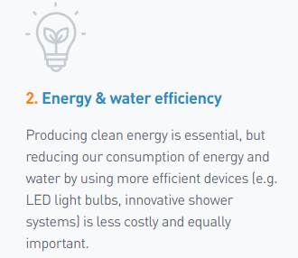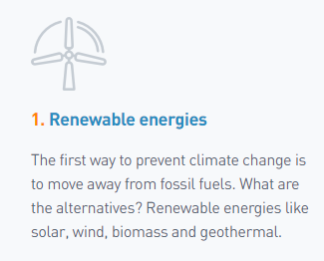

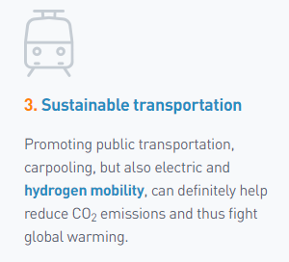

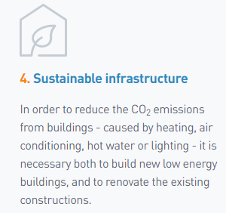

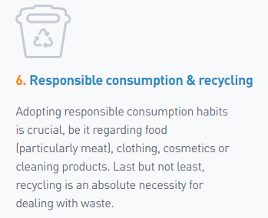

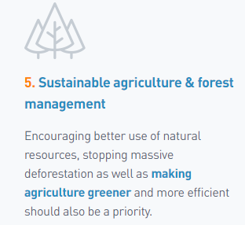

**ENERGY STORAGE**

What is energy storage system?:- Energy storage systems are technology or system, in which electric energy is loaded in and, by necessity, can lately be discharged into the network.

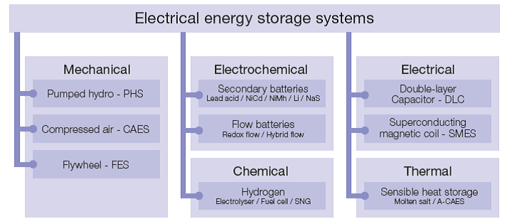

1. **Pumped storage hydro** – the most successful energy storage systems due to their fast response and storage capacity, pumped storage hydro have been proven to be excellent reserves. The world installed capacity is about 135GW. Conventionally, two water reservoirs at different elevations are used to pump water during off peak hours from the lower to the upper reservoir (charging) and the water flows back to move a turbine and generate electricity (discharging) when required.
2. **Compressed air energy storage (CAES)** – 440MW of installations exists around the world.  This technology is based on the conventional gas turbines and stores energy by compressing air in an underground storage cavern. Electricity is used to compress air and when needed the compressed air is mixed with natural gas, burned and expanded in a modified gas turbine.
3. **Flywheels** – rotational energy is stored in a large rotational cylinder where the energy is maintained by keeping its speed constant.  A transmission device is used to accelerate or decelerate the flywheel by supplying and extracting electricity. When the speed is increased higher amounts of energy are stored.
4. **Battery-** is a device consisting of one or more [electrochemical cells](https://en.wikipedia.org/wiki/Electrochemical_cell) with external connectionsfor powering electrical devices such as [flashlights](https://en.wikipedia.org/wiki/Flashlight), [mobile phones](https://en.wikipedia.org/wiki/Mobile_phone), and [electric cars](https://en.wikipedia.org/wiki/Electric_car). When a battery is supplying [electric power](https://en.wikipedia.org/wiki/Electric_power), its positive terminal is the [cathode](https://en.wikipedia.org/wiki/Cathode) and its negative terminal is the [anode](https://en.wikipedia.org/wiki/Anode).The terminal marked negative is the source of electrons that will flow through an external electric circuit to the positive terminal. When a battery is connected to an external electric load, a [redox](https://en.wikipedia.org/wiki/Redox) reaction converts high-energy reactants to lower-energy products, and the [free-energy](https://en.wikipedia.org/wiki/Gibbs_free_energy) difference is delivered to the external circuit as electrical energy
5. **Electric Double layer capacitors** - super capacitors to provide backup for computer memory. Later used in space applications, aircrafts etc, these EES have very long life and can withstand lakhs of cycles.
6. **Super conducting magnetic energy storage** - stores the energy in the magnetic field created in the coil for an indefinite period of time.
7. **Thermal storage** – systems use cold water, hot water or ice storage to store the heat and use for later. The efficiencies vary with the material. They are important for integrating large scale renewable energy as concentrated solar thermal technology can be used as a reliable and despicable source of energy to balance the supply and demand.

One of the distinctive characteristics of the electric power sector is that the amount of electricity that can be generated is relatively fixed over short periods of time, although demand for electricity fluctuates throughout the day. Developing technology to store electrical energy so it can be available to meet demand whenever needed would represent a major breakthrough in electricity distribution. Helping to try and meet this goal, electricity storage devices can manage the amount of power required to supply customers at times when need is greatest, which is during peak load. These devices can also help make renewable energy, whose power output cannot be controlled by grid operators, smooth and dispatch able.

They can also balance microgrids to achieve a good match between generation and load. Storage devices can provide frequency regulation to maintain the balance between the network's load and power generated, and they can achieve a more reliable power supply for high tech industrial facilities. Thus, energy storage and power electronics hold substantial promise for transforming the electric power industry.

Enhanced energy storage can provide multiple benefits to both the power industry and its customers. Among these benefits are:

* Improved power quality and the reliable delivery of electricity to customers;
* Improved stability and reliability of transmission and distribution systems;
* Increased use of existing equipment, thereby deferring or eliminating costly upgrades;
* Improved availability and increased market value of distributed generation sources;
* Improved value of renewable energy generation

**ENERGY CONSERVATION**

**Energy conservation** is the effort made to reduce the consumption of **energy** by using less of an **energy** service. This can be achieved either by using **energy** more efficiently (using less **energy** for a constant service) or by reducing the amount of service used. Energy conservation is a part of the concept of Eco-sufficiency. Energy conservation reduces the need for energy services and can result in increased environmental quality, national security, personal financial security and higher savings. It also lowers energy costs by preventing future resource depletion.

**WAYS TO ENERGY CONSERVATION**

### Adjust your day-to-day behaviors:- Energy conservation can be as simple as turning off lights or appliances when you do not need them. You can also use energy-intensive appliances less by performing household tasks manually, such as hang-drying your clothes instead of putting them in the dryer, or washing dishes by hand.

### 2. Replace your light bulbs:- Traditional incandescent light bulbs consume an excessive amount of electricity and must be replaced more often than their energy efficient alternatives. Halogen incandescent bulbs, compact fluorescent lights (CFLs), and light-emitting diode bulbs (LEDs) use anywhere from 25-80% less electricity and last three to 25 times longer than traditional bulbs.

**3. Install a programmable or smart thermostat:-** A programmable or smart thermostat can be set to automatically turn off or reduce heating and cooling during the times when you are asleep or away. When you install a programmable thermostat, you eliminate wasteful energy use from heating and cooling without upgrading your HVAC system or sacrificing any comfort.

4. **Purchase energy efficient appliances:**- On average, appliances are responsible for roughly 13% of your total household energy use. When purchasing an appliance, you should pay attention to two numbers: the initial purchase price and the annual operating cost. Although energy efficient appliances usually have higher purchase prices, their operating costs are 9-25% lower than conventional models.

### 5. Reduce your water heating expenses:- Water heating is a major contributor to your total energy consumption. Other than purchasing an energy efficient water heater, there are three methods of reducing your water heating expenses: you can simply use less hot water, turn down the thermostat on your water heater, or insulate your water heater and the first six feet of hot and cold water pipes.

6. Install energy efficient windows:- Windows are significant source of energy waste, which can amount to 10-25% of your total heating bill. To prevent heat loss through your windows, you can replace single-pane windows with double-pane ones.

### 7. Upgrade your HVAC system:- An HVAC system is composed of heating, ventilation, and air conditioning equipment. Heating alone is responsible for more than 40% of home energy use. Because homes in Northern regions are exposed to much colder temperatures during the year, ENERGY STAR gas furnaces have different specifications in the northern and southern halves of the United States.

Air conditioning, by comparison, isn’t a significant contributor to energy bills – on average, it only makes up six percent of the total energy use of your home. ENERGY STAR central air conditioning units are eight percent more efficient than conventional models.

Upgrades to the third component of an HVAC system – ventilation – can also improve your energy efficiency. A ventilation system is composed of a network of ducts, which distributes hot and cold air throughout your home.

### 8. Weatherize your home:- Weatherizing, or sealing air leaks around your home, is a great way to reduce your heating and cooling expenses. The most common sources of air leaks into your home are vents, windows, and doors. To prevent these leaks, you should ensure that there are no cracks or openings between the wall and vent, window, or doorframe.

* **Engineering For Energy conservation:- Energy** engineering or Energy Systems Engineering is a broad field of [engineering](https://en.wikipedia.org/wiki/Engineering) dealing with [energy efficiency](https://en.wikipedia.org/wiki/Efficient_energy_use), [energy services](https://en.wikipedia.org/wiki/Energy_services), [facility management](https://en.wikipedia.org/wiki/Facility_management), plant engineering, [environmental compliance](https://en.wikipedia.org/wiki/Environmental_compliance), [sustainable energy](https://en.wikipedia.org/wiki/Sustainable_energy) and [renewable energy](https://en.wikipedia.org/wiki/Renewable_energy) technologies.
* Energy engineering is one of the more recent engineering disciplines to emerge. Energy engineering combines knowledge from the fields of [physics](https://en.wikipedia.org/wiki/Physics), [math](https://en.wikipedia.org/wiki/Math), and [chemistry](https://en.wikipedia.org/wiki/Chemistry) with economic and environmental engineering practices.
* Energy engineers apply their skills to increase efficiency and further develop renewable sources of energy.
* The main job of energy engineers is to find the most efficient and sustainable ways to operate buildings and manufacturing processes
* Energy engineers audit the use of energy in those processes and suggest ways to improve the systems.
* suggesting advanced lighting, better insulation, more efficient heating and cooling properties of buildings.
* Energy engineer is concerned about obtaining and using energy in the most environmentally friendly ways, their field is not limited to strictly renewable energy like hydro, solar, biomass, or geothermal.

**Green Building**

A ‘green’ building is a building that, in its design, construction or operation, reduces or eliminates negative impacts, and can create positive impacts, on our climate and natural environment. Green buildings preserve precious natural resources and improve our quality of life.

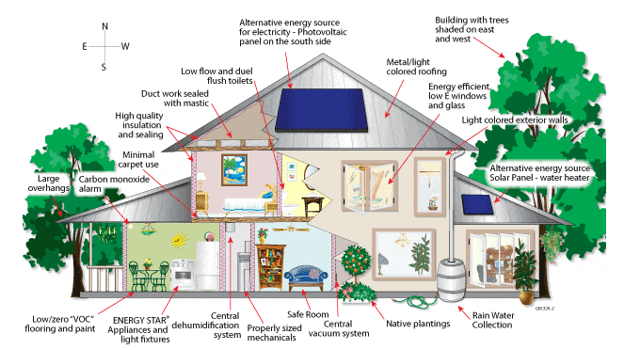

* **CONSIDERATION FOR GREEN BUILDING:-** Green building involves consideration in four main areas: site development, material selection and minimization, energy efficiency, and indoor air quality

1 site development:- to reduce the impact of development on the natural environment. For example, orient the buildings to take advantage of solar access, shading and wind patterns that will lessen heating and cooling loads.

2 select materials that are durable, contain recycled content, and are locally manufactured to reduce negative environmental impacts. A growing market exists of quality recycled products at affordable prices.

3.energy-efficient design into buildings to create an efficient and comfortable environment. Take advantage of the natural elements and technologies to conserve resources and increase occupant comfort/productivity while lowering long-term operational costs and pollutants (CBFEE, 1999).

4. Design for high indoor air quality to promote occupant health and productivity.

**THE PRINCIPLES OF GREEN BUILDING DESIGN:-   
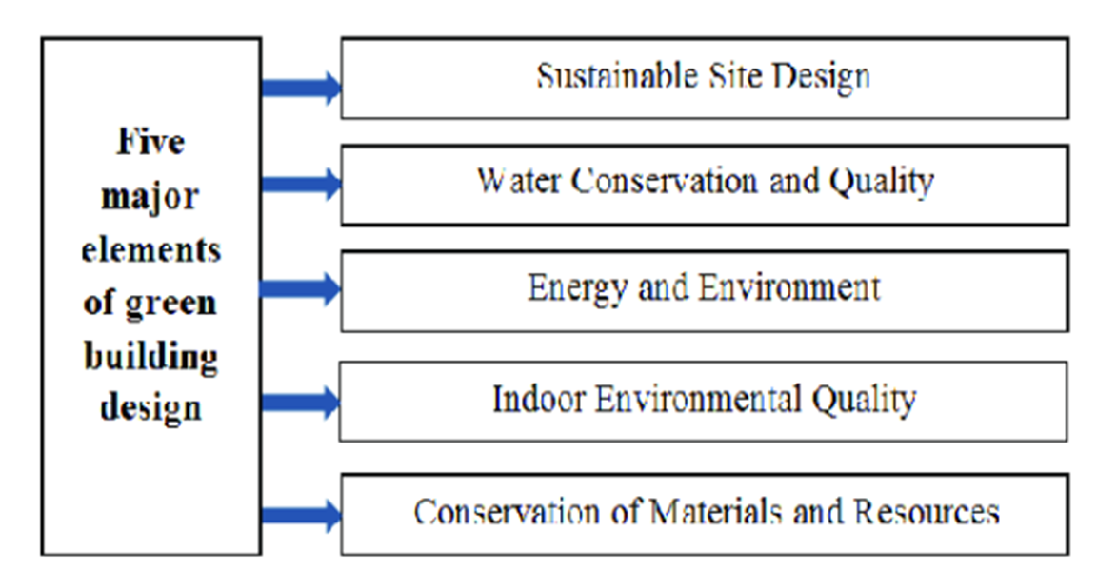**

**There are a number of features which can make a building ‘green’. These include:**

* Efficient use of energy, water and other resources
* Use of renewable energy, such as solar energy
* Pollution and waste reduction measures, and the enabling of re-use and recycling
* Good indoor environmental air quality
* Use of materials that are non-toxic, ethical and sustainable
* Consideration of the environment in design, construction and operation
* Consideration of the quality of life of occupants in design, construction and operation
* A design that enables adaptation to a changing environment
* Ventilation systems designed for efficient heating and cooling
* Energy-efficient lighting and appliances (e.g., [ENERGY STAR](https://www.energystar.gov/)® products)
* Water-saving plumbing fixtures
* Minimal harm to the natural habitat
* Alternative renewable energy power sources such as solar power or wind power
* Non-synthetic, non-toxic materials used inside and out
* Optimal location on the land, maximizing sunlight, winds, and natural sheltering

Any building can be a green building, whether it’s a home, an office, a school, a hospital, a community centre, or any other type of structure, provided it includes features listed above.

However, it is worth noting that not all green buildings are – and need to be - the same. Different countries and regions have a variety of characteristics such as distinctive climatic conditions, unique cultures and traditions, diverse building types and ages, or wide-ranging environmental, economic and social priorities – all of which shape their approach to green building. This is why World GBC supports its member Green Building Councils and their member companies in individual countries and across regions, to pursue green buildings that are best suited to their own markets.

**LEED rating?**

**What does LEED rating stand for?:-** LEED, which stands for **Leadership in Energy and Environmental Design**, is a certification program focused primarily on new, commercial-building projects and based upon a points system.

The LEED rating system has seven areas of concentration;

* Sustainable Sites
* Water Efficiency
* Energy and Atmosphere
* Materials and Resources
* Indoor Environmental Quality
* Innovation in Design Process
* Regional Priority

Projects obtain credits in these areas to achieve certification. A building becomes certified after receiving a minimum of 40 credits from the USGBC (United States Green Building Council).

LEED Certification Levels

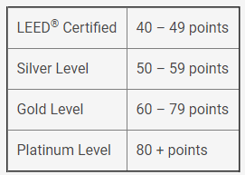

The point distribution over the seven categories is as follows:

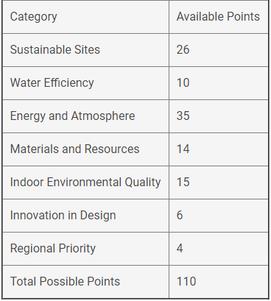

**EMBODIED ENERGY**:- ANALYSIS AND USE AS A TOOL FOR MEASURING SUSTAINABILITY

Embodied energy is the total energy required for the extraction, processing, manufacture and delivery of building materials to the building site. Energy consumption produces CO2, which contributes to greenhouse gas emissions, so embodied energy is considered an indicator of the overall environmental impact of building materials and systems.

**How is embodied energy measured?:-** Embodied energy is measured as the quantity of non-renewable energy per unit of building material, component or system. It is expressed in megajoules (MJ) or gigajoules (GJ) per unit weight (kg or tonne) or area (m2) but the process of calculating embodied energy is complex and involves numerous sources of data.

When selecting building materials, the embodied energy should be considered with respect to:

* the durability of building materials
* how easily materials can be separated
* use of locally sourced materials
* use of recycled materials
* specifying standard sizes of materials
* avoiding waste
* Selecting materials that are manufactured using renewable energy sources.

**why reduced embodied energy?-** The total amount of embodied energy may account for 20% of the building's energy use, so reducing embodied energy can significantly reduce the overall environmental impact of the building.

Embodied energy is the front-end component of the lifecycle impact of a building – and it is the part that can never be changed. ... Not only does the manufacturing of building materials have significant energy-related GHG emissions, but it also causes high levels of air pollution.

* **How can embodied energy be reduced?:-** The easiest way to reduce embodied carbon is to consume fewer resources. That can mean less new construction, smaller new construction, less materials in new construction, and less frequent material replacements.

**ENERGY AUDIT**

Energy audit is a survey to identify how energy is being used in a building or plant, and identifies energy savings opportunities. Using proper audit methods and equipment, an energy audit provides the energy manager with essential information on how much, where and how energy is used within an organization (factory or building).

**Types of energy audit:-** Basically there are three types of energy audit:

1. Walk-Through Audit (WTA): as the name suggests, this audit consists of a walk-through inspection of a facility to identify maintenance, operational or deficient equipment issues and also to identify areas that need further evaluation.
2. Energy Diagnosis: this audit includes performing economic calculations and may include using some metering devices to identify actual energy consumption and losses.
3. Investment Grade Audit (IGA): this audit is a detailed account of energy use, including a quantitative study of the implementation with detailed investments and operational and maintenance costs and an analysis of the investment model.

**Energy Audit process**

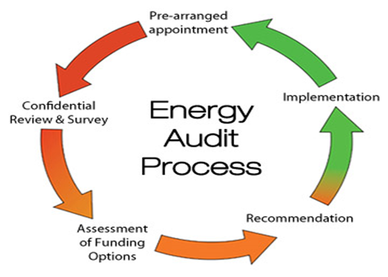

What are the benefits of doing an energy audit?

* It helps reduce energy costs in your facility.
* With a reduction in production costs, the competitiveness of your company will be improved.
* It helps reduce environmental damage and pollution.
* It can increase the security of your energy supply.
* It can reduce damage to the environment associated with the exploitation of resources.
* It helps reduce the impact of greenhouse gas emissions.
* It helps you to lower energy bills.
* It enables you to increase the comfort of those in the facility.
* It helps you to increase the life span of the equipment in your facility.
* It discovers any unaccounted consumption that may exist at the facility.

**OPTIMIZATION OF ENERGY CONSUMPTION**

**Energy optimization is an important issue for all operations in any industry and it has been considered a cost reduction method**. In recent years, there has been an increasing interest within this area due to the increasing concern of the ambient air quality, the sustainable use of resources and the tightening regulations on emission. Companies have to apply energy optimizing solutions not only for decreasing the normal operation cost but also to comply with all the environmental requirements in an economical way.

**5 Steps to Reduce Your Energy Consumption**



Computers are some of the biggest energy users in office buildings. Turn your monitor off at night and ditch the screensaver. Today's computers can be turned on and off over 40,000 times. Opting to shut down over using a screensaver does not affect your computer's lifespan. (EnergyStar). So power down.



LED bulbs are the most energy efficient lighting option. LED bulbs use 75% less electricity than incandescent bulbs (Energy Star). The also have no mercury, and last about 25 times longer than traditional incandescent bulbs (DoE).

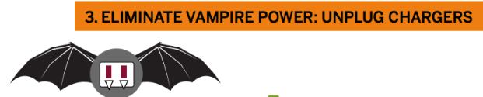

Devices like televisions, microwaves, scanners, and printers use standby power, even when off. Some chargers continue to pull small amounts of energy, even when plugged in



To avoid paying for this "vampire power," use a power strip to turn all devices off at once. Flipping the switch on your power strip has the same effect as unplugging each socket from the wall, preventing energy loss.

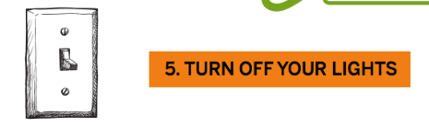

Just one switch and you're done